Clean Code Principles - Single Responsibility Principle (SRP)
# Source: AI Source: Provided by: [Data Path: Persons Table -> ID Column: 1, Name_En Column: Motasem Essam] -> From: [Chatgpt (GPT‑5 Mini)] on [12/9/2025]
The Single Responsibility Principle (SRP) states that a class or function should have only one reason to change—meaning it should focus on one responsibility only.

🔑 Why SRP Matters
# Source: AI Source: Provided by: [Data Path: Persons Table -> ID Column: 1, Name_En Column: Motasem Essam] -> From: [Chatgpt (GPT‑5 Mini)] on [12/9/2025]
- Makes code easier to understand
- Improves maintainability
- Reduces bugs and side effects
- Makes testing easier
- Encourages better separation of concerns

✅ Good Example
# Source: AI Source: Provided by: [Data Path: Persons Table -> ID Column: 1, Name_En Column: Motasem Essam] -> From: [Chatgpt (GPT‑5 Mini)] on [12/9/2025]
A class that only handles user validation:
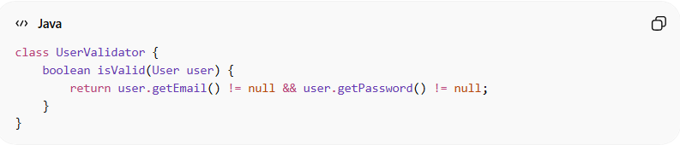
class UserValidator {
boolean isValid(User user) {
return user.getEmail() != null && user.getPassword() != null;
}
}

❌ Bad Example
# Source: AI Source: Provided by: [Data Path: Persons Table -> ID Column: 1, Name_En Column: Motasem Essam] -> From: [Chatgpt (GPT‑5 Mini)] on [12/9/2025]
A class handling multiple responsibilities:
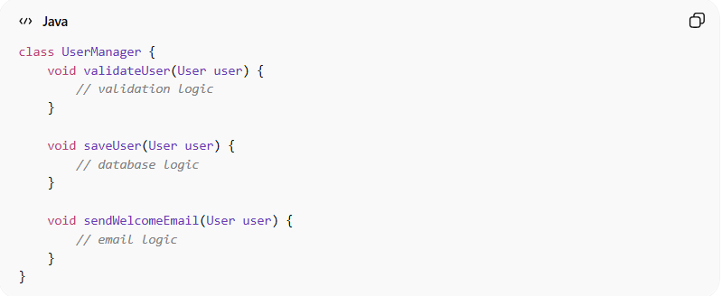
class UserManager {
void validateUser(User user) {
// validation logic
}

void saveUser(User user) {
// database logic
}

void sendWelcomeEmail(User user) {
// email logic
}
}
👉 This class does validation, saving, and emailing — too many responsibilities in one place.

✅ Refactored (SRP Applied)
# Source: AI Source: Provided by: [Data Path: Persons Table -> ID Column: 1, Name_En Column: Motasem Essam] -> From: [Chatgpt (GPT‑5 Mini)] on [12/9/2025]
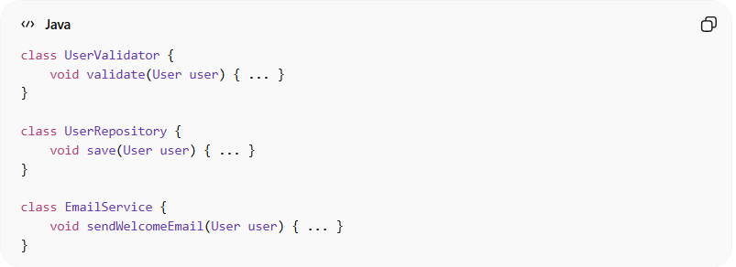
class UserValidator {
void validate(User user) { ... }
}

class UserRepository {
void save(User user) { ... }
}

class EmailService {
void sendWelcomeEmail(User user) { ... }
}

💡 Key Idea
# Source: AI Source: Provided by: [Data Path: Persons Table -> ID Column: 1, Name_En Column: Motasem Essam] -> From: [Chatgpt (GPT‑5 Mini)] on [12/9/2025]
Each class or function should have one job and one reason to change.

🚫 Common SRP Violations
# Source: AI Source: Provided by: [Data Path: Persons Table -> ID Column: 1, Name_En Column: Motasem Essam] -> From: [Chatgpt (GPT‑5 Mini)] on [12/9/2025]
- A class that handles logic + database + UI
- A function that performs multiple unrelated tasks
- Mixing business logic with infrastructure logic

🧾 Summary
# Source: AI Source: Provided by: [Data Path: Persons Table -> ID Column: 1, Name_En Column: Motasem Essam] -> From: [Chatgpt (GPT‑5 Mini)] on [12/9/2025]
Following SRP helps you:
- Build modular and decoupled code
- Make changes without affecting unrelated parts
- Improve overall system design

